OPERATING SYSTEMS
WEEK-01 PRACTICAL

NAME : NARLA MADHAN GOPAL
ROLL NO : 2520030263
SECTION -07
O/P:

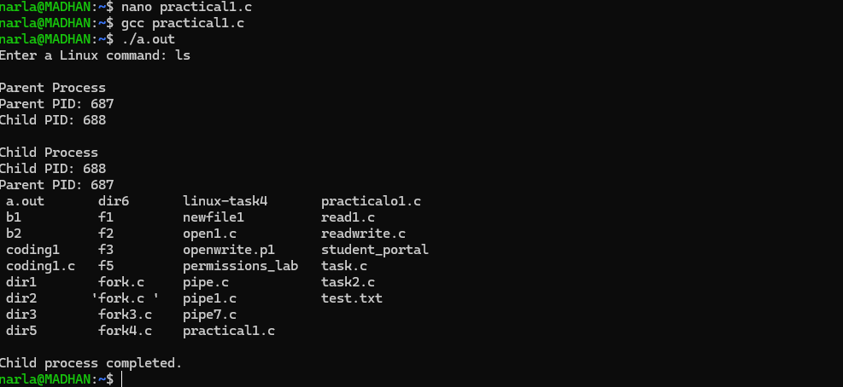

>Using Linux terminal commands (uname, lscpu, lsblk, ps, top), investigate the relationship between hardware resources and operating system services. Prepare a report explaining how the OS abstracts CPU, memory, storage, and I/O devices.
-uname
-lscpu
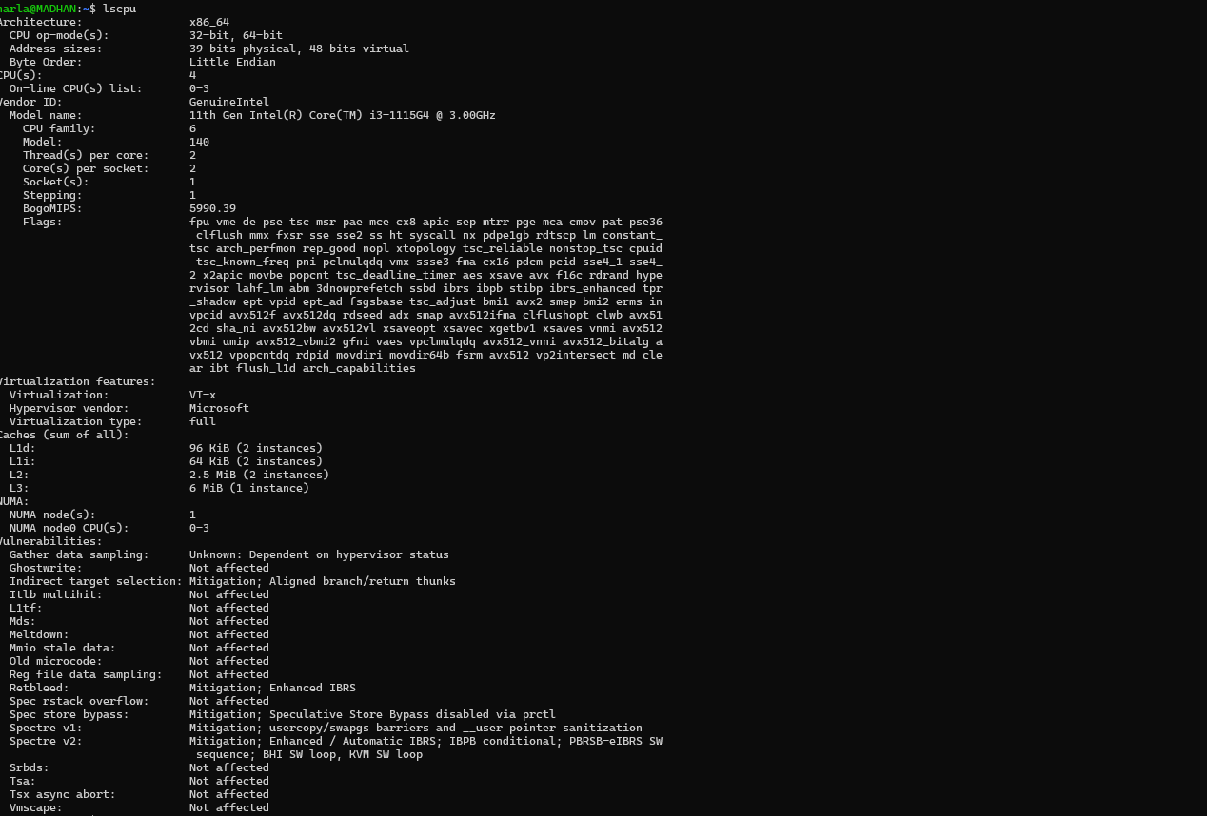
-lsblk
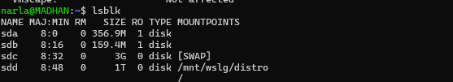
-ps
-top

